**Introduction to JavaScript**

**Date 10/02/2021**

**Exercise**

1. **Prompt for amount, interest rate and no. of years and calculate simple interest.**

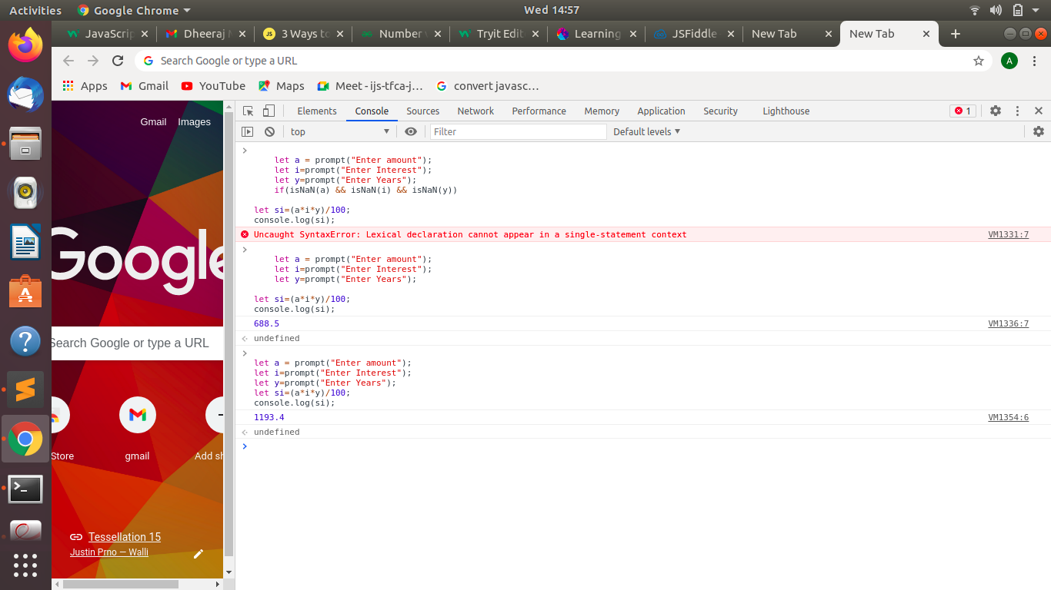

1. **is palindrome string.**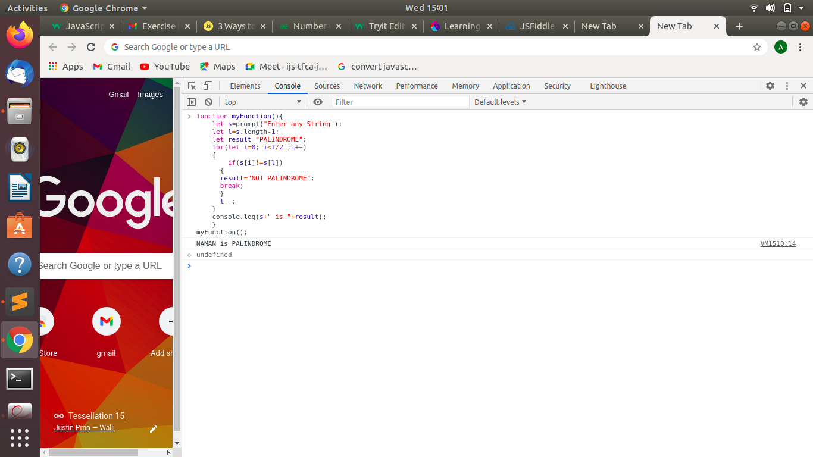
2. **Area of circle**

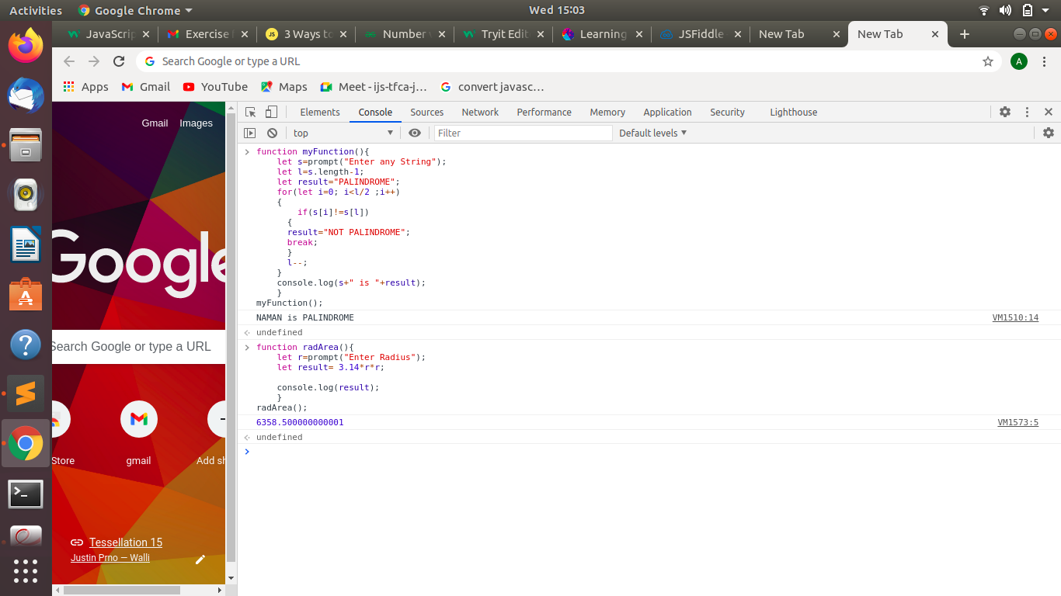

1. **Copy information of one object to another and log it to console.**

**There are two methods of doing this.**

1. **Shallow Copy:**

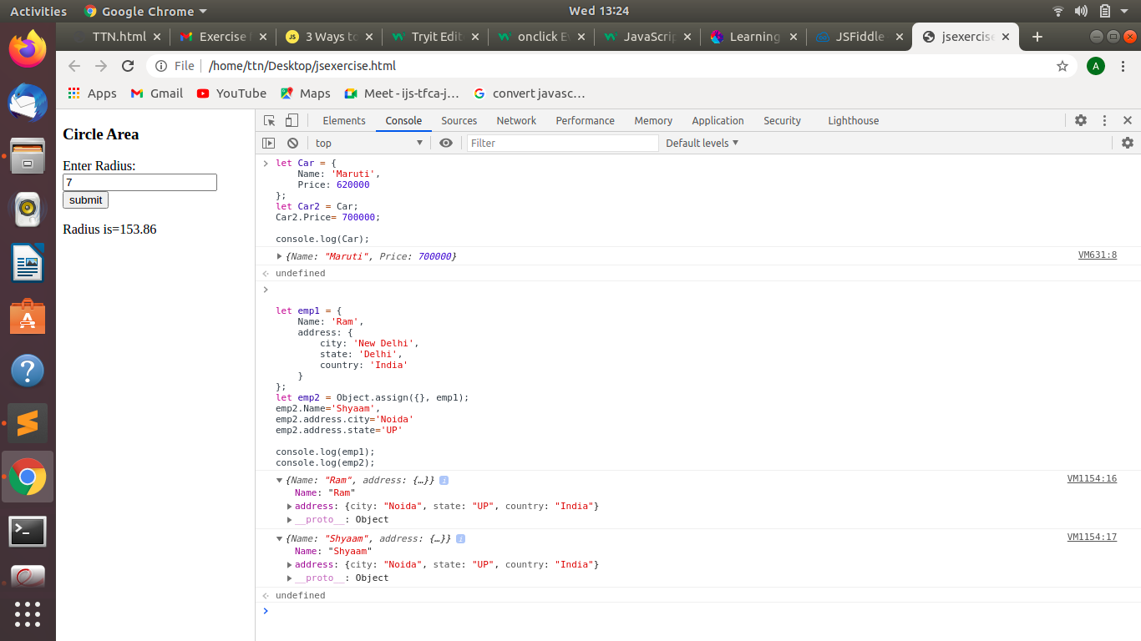

1. **Deep Copy:**

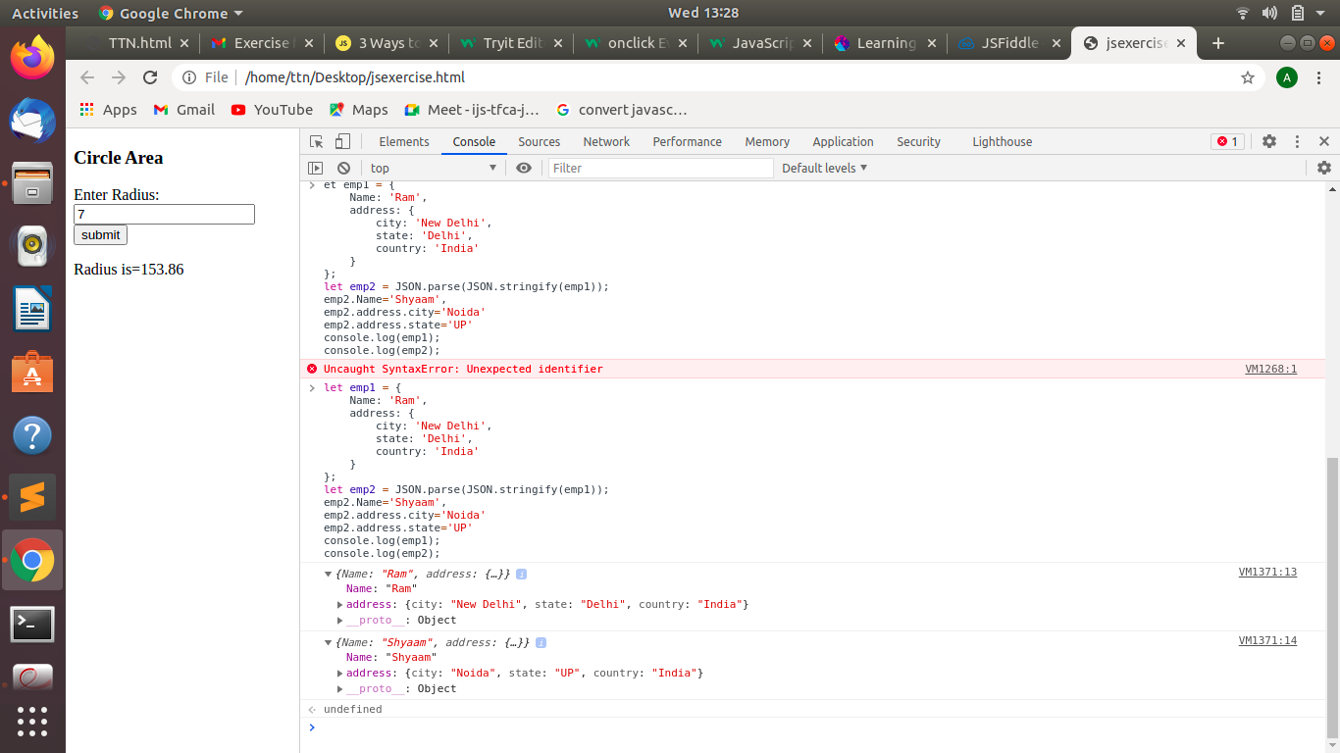

1. **create a list of objects of Employee with info as follow :**
   * **Name, age, salary ,DOB**
   * 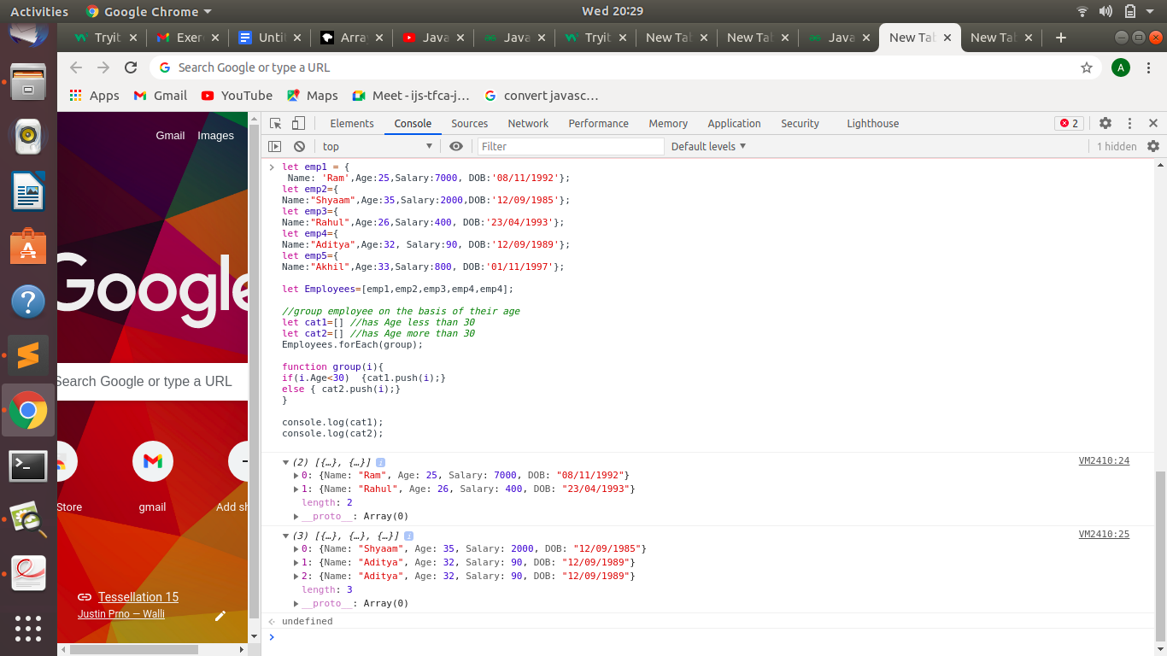
   * **filter all employees with salary greater than 5000.**
   * 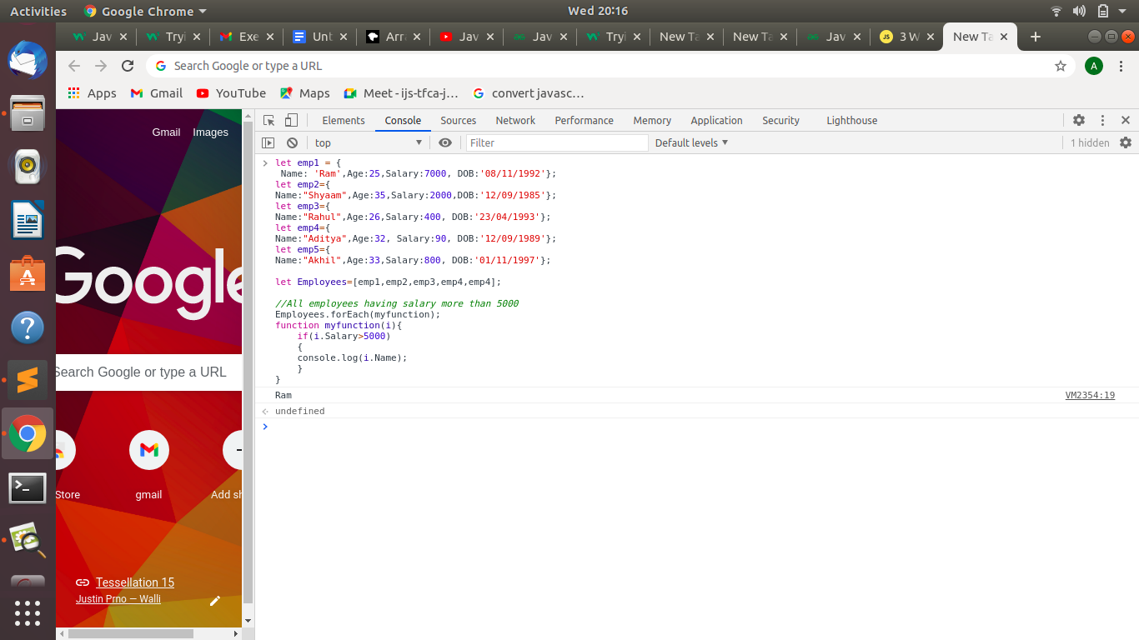
   * **group employee on the basis of their age.**
   * 
   * **fetch employees with salary less than 1000 and age greater than 20. Then give them an increment 5 times their salary.**
   * 